DEBARAJ MAHAKUR
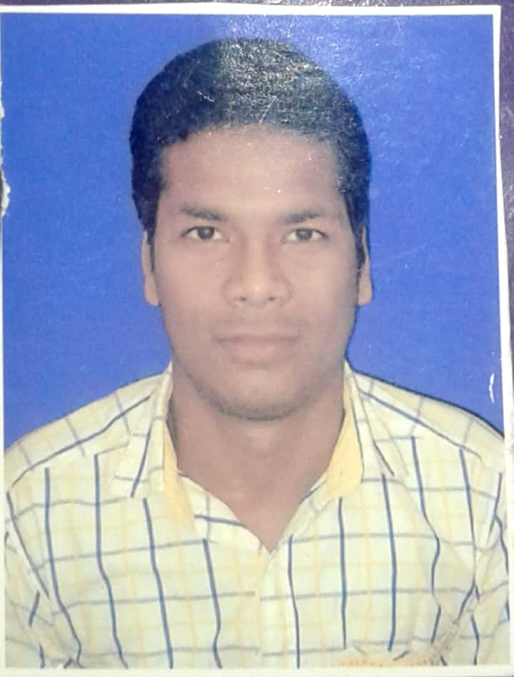
Mobile: +919777196407
Email id : MAHAKURLPDEV@GMAIL.COM

Carrer Objective

To work in a professional, dynamic and vibrant environment and to keep value adding to the organization which I represent and serve while concurrently upgrading my skill, knowledge and competence

Professional Experience 01 year

01-NLC INDIA LTD (A NAVARATNA GOVT OF INDIA ENTERPRISE).NEYVELI, TAMILNADU AS INDUSTRIAL TRAINEE - FINANCE FROM 03..10.2018-.02.10.2019

AREAS OF WORK---- Accounts , Taxation & FINACIAL WORKs

- Preparing and Processing of Revenue work bills and also Preparing Payment Vouchers and make Entry in book of accounts.
- Process vendor & supplier invoice & make entry in books of accounts
- Make vendor payment in bank corporate portal & make accounts receivable
- Monthly BANK Reconciliation Statement
- Statutory Compliance & Regular reporting
- Preparation of Exchequer Report.
- Preparing Statements and Vouchers of Statutory remittance.
- Preparation of Monthly MIS Report and Consolidation of Accounting Schedules.
- TDS (both income tax & GST)
- GST Reconciliation
- Preparation of cost statement
- Preparation of Schedules for various General Ledger (GL) Codes.
- Review of General Ledger & passing necessary Journal entries every month.
- Reconciliation of Various GLs.

EDUCATIONAL QUALIFICATIONS:

Professional Qualification
Professional Nomenclature | Institute | Year of Passing & Marks in (%)
CMA(CWA) INTER | Institute Of Cost And Management Accountants Of India | AUG 2017 & 53.13

Academic Qualifications
Examination Passed | Board /School /College /University | Year of passing & Marks in (%)
B. Com (Hons.) | GANGADHAR MEHER (AUTO) COLLEGE SAMBALPUR, ODISHA.  (SAMBALPUR UNIVERCITY) | 2015with 69.22%
XII Standard | PANCHAYAT SAMITI COLLEGE ULUNDA.ODISHA (CHSE ODISHA BOARD) | 2012 with 79.83%
X Standard | PANCHAYAT HIGH SCHOOL LUTURPANK.  (BSE ODISHA) | 2010 with 73.67%

Computer Skills
- Completed Information Technology Training of 100 hours from Institute of Cost Accountants of India.
- SAP-FICO, MS office (Word, Excel, and Power point), Internet application.
- Knowledge of Advance excel (Pivot table, VLookup, H lookup, if function, and or Function etc.)

Personal Details
Fathers Name: | Mr. PADMANABHA MAHAKUR
Date of Birth: | 15 JUNE 1995
Present Address: | AT-Neelam CHAMBER ,NEAT FATAK RAILWAY STATION,PO-BUDHARAJA,PS-AINTHAPALI, DISTRICT-SAMBALPUR pin-768004  ODISHA
Permanent Address: | AT/PO-LUTURPANK ,PS-SUBALAYA ,DIST-SUBARNAPUR ,PIN-767018 ODISHA
Areas of Strength: | Positive approach to challenges
Languages known: | English, Hindi & ODIA(ORIYA)
Contact | 6370264701,9777196407

I do hereby declare that the above given details are true to my knowledge.

